**QRM Project02 Report**

**Question 1:**

**A:**

Arithmetic returns are calculated using:

And then the mean of each stock’s return series is subtracted to ensure a zero mean.

The last 5 rows of the result are followings:

standard deviation of each stock:

total standard deviation:



**B:**

Log returns are computed using:

And then the mean of each stock’s return series is subtracted to ensure a zero mean.

The last 5 rows of the result are followings:

standard deviation of each stock:

total standard deviation:



**The total standard deviation (sum of individual standard deviations) is very similar for arithmetic and log returns.**

**Question 2:**

**A:**

First get the price of each stock on January 3, 2025. And then calculate the portfolio by using this formula:

The result is following:

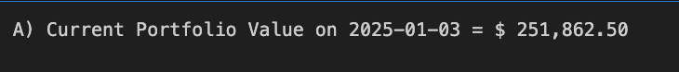

**B:**

**2a:**

The first step is calculating arithmetic returns,

and then the mean return is subtracted from the return series to ensure a zero-mean assumption:

This is the function from project01 calculate ewcov:

Then using this formular Computing Exponentially Weighted Covariance Matrix，

The next step is preparing the Standard normal quantile for 5% level:

z-score for 5% quantile by using this function: z05 = norm.ppf(alpha)

Probability density at VaR threshold by using this function: pdf_z05 = norm.pdf(z05)

The formular to calculate the var is:

The formular to calculate the ES is:

The is the result are followings:

**VaR Interpretation:**

The 5% VaR of $3,856.32 means that under normal market conditions, there is a 5% probability that the portfolio will lose more than $3,856.32 in a single day.

**Expected Shortfall (ES) Interpretation:**

The ES (or Conditional VaR) of $4,835.98 represents the average loss expected if the portfolio exceeds the VaR threshold.

**2b:**

The first two steps are same to 2a, so that we can got the portfolio value and remove the mean value.

**Step 1: Then for each stock, a Student’s T-distribution is fitted to the adjusted return data using Maximum Likelihood Estimation (MLE)**

**Step 2: Transforming Returns into Copula Space should using following steps:**

1 The empirical cumulative distribution function (CDF) is applied to each stock’s return data:

2 The inverse normal transformation is applied to convert them into **standard normal variables**:

**Step 3: Then we can Simulating Returns Using a T-Copula:**

A Gaussian Copula with Spearman rank correlation is used to generate correlated normal variables:

The simulated values are mapped back to the **T-distribution** using the **inverse CDF transformation** by using this formula:

**Step 4: Then we do the Portfolio PnL Simulation**

The latest stock prices are retrieved from the dataset, and simulated portfolio PnLs are calculated:

**Step 5:** **Calculating VaR and ES:**

VaR at 5% level:

Expected Shortfall (ES) at 5% level:

After finishing the steps above, we can get the result:

**VaR Interpretation**:

The 5% VaR of $4,464.07 means that under normal market conditions, there is a 5% probability that the portfolio will lose more than $4,464.07 in a single day

**Expected Shortfall (ES) Interpretation**:

The ES (or Conditional VaR) of $6,116.37 represents the average loss expected if the portfolio exceeds the VaR threshold.

**2C:**

The first two steps are same to 2a, so that we can got the portfolio value and remove the mean value.

Then the portfolio profit and loss (PnL) is calculated by weighting each stock’s return by its current holdings and price

**Then we can calculate the Var:**

Historical VaR is determined by taking the 5th percentile of the simulated portfolio PnL distribution:

**Expected Shortfall (ES) is computed as the average loss beyond the VaR threshold:**

The result are followings:

**VaR Interpretation:**

The 5% Historical VaR of $4,575.03 means that in the worst 5% of observed historical trading days, the portfolio is expected to lose at least this amount.

**Expected Shortfall (ES) Interpretation:**

The 5% Historical ES of $6,059.39 represents the average loss in cases where the portfolio loss exceeds the VaR threshold.

**C:**

The Normal Distribution + Exponentially Weighted Covariance (EWMA) Method assumes asset returns follow a normal distribution and applies exponential weighting to prioritize recent data. It is computationally efficient and suitable for stable markets but tends to underestimate extreme losses due to its normality assumption. In this calculation, it produced a 5% VaR of $3,856.32 and a 5% ES of $4,835.98, the lowest among the three methods. The t-Distribution + Gaussian Copula Method models fat-tail characteristics using a t-distribution and captures nonlinear dependencies between assets through the Copula approach. It is more accurate in extreme risk estimation but computationally intensive. This method yielded a 5% VaR of $4,464.07 and a 5% ES of $6,116.37, the highest ES among the methods, indicating its strong ability to capture tail risk. The Historical Simulation Method directly calculates VaR and ES using past data without assuming a specific return distribution. It is intuitive and realistic but dependent on historical patterns, which may not always predict future risks. The results, 5% VaR of $4,575.03 and 5% ES of $6,059.39, are close to the t-Copula method, reflecting historical extreme losses. Normal Distribution Method is efficient but underestimates risk due to normality assumptions. t-Copula Method captures fat tails and nonlinear correlations, making it suitable for extreme market conditions. Historical Simulation provides realistic estimates but relies on past data, making it vulnerable to structural market changes. Overall, t-Copula and Historical Simulation methods provide more robust risk estimations, while EWMA is faster but less accurate in turbulent markets.

**Question 3:**

Because there are no dividends are paid. Thus 𝑟=𝑏

And because it is European Call option with so we can apply the bs formular to calculate the parameters.

call_price_bs formula:

put_price_bs formula:

D1, D2 formula:

**A:**

So, we can use this formula to solve the equation, and get the implied volatility

The result is behind:



Implied volatility (IV) represents the market's expectation of the underlying asset's future volatility over the option's remaining lifespan. A value of 33.51% means that the market anticipates the stock price to fluctuate at an annualized standard deviation of 33.51%.

**B:**

**The formula to get Delta:**

The result is that：

Delta of Call = 0.6659

This means that when the underlying stock price increases by $1.00, the call option price is expected to increase by $0.6659.

Delta of put = -0.3341

This means that when the underlying stock price increases by $1.00, the put option price is expected to decrease by $0.3341.

**The formula to get Vega:**

The result is that：

Vega of Call = 5.6407

This means that when the implied volatility increases by 1% (0.01 in decimal form), the option price is expected to increase by $0.0564.

Since Vega is derived purely from d1​ and the normal density function, and since changes in volatility impact the probability of moneyness symmetrically for calls and puts, **Vega is identical for both call and put options.**

**The formula to get Theta of Call:**

The result is that：

Theta of Call = -5.5446

This represents the time decay of the option. It means that, on average, the option loses about $5.54/365 ≈ $0.0152 per day due to the passage of time, assuming all other factors remain constant.

**The formula to get Theta of put:**

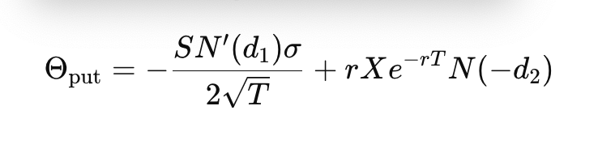

The result is that:

Theta of Put = −2.6186

This represents the time decay of the put option. It means that, on average, the put option loses about 2.6186/365≈0.0072per day due to the passage of time, assuming all other factors remain constant.

Actual Price Change:

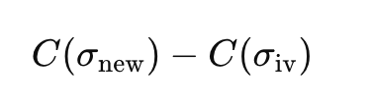

Vega Approximation:

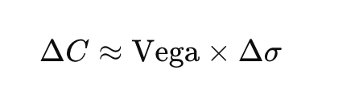

The result are following:

The Actual Price Change is 0.0565, and Vega Approximation is 0.0564

The actual and approximated price changes are very close (0.0565 vs. 0.0564), confirming that Vega provides a reliable linear approximation when the change in volatility is small.

**C:**

Put-Call Parity:

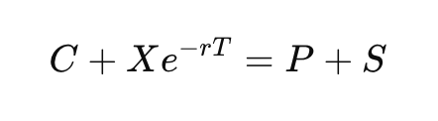

We can use put_price_bs function I created to get the P = 1.2593, and S is given is 31

So, the right-hand side is 32.2593

Call Price is given =3, and Xe-rt = 29.2593 so the left-hand side is also 32.2593,

To sum up, we can prove that Put-Call Parity holds exactly

**D：**

At first, we should calculate the initial portfolio value:

By using the function call_price_bs, put_price_bs calculate call_0, put_0

And the calculate the portfolio value = call_0 + put_0 + stock price

The following are the results:

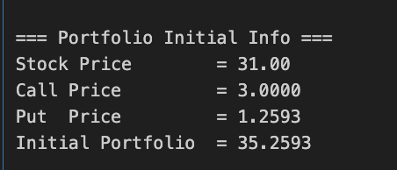

**a. Delta Normal Approximation:**

Then we should calculate the delta of portfolio:

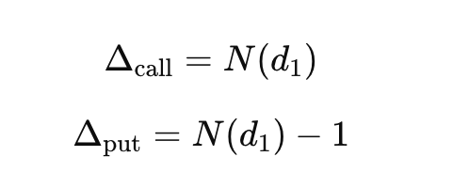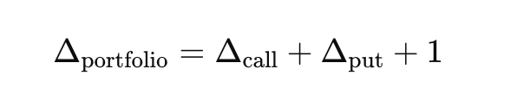

**The result are following:**

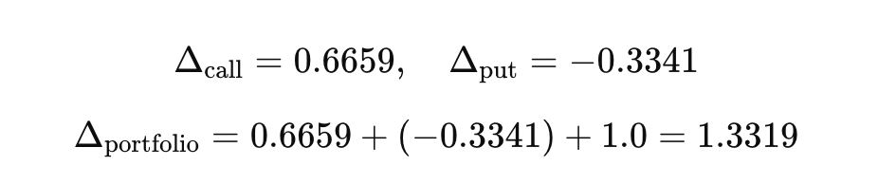

**Portfolio Theta Calculation:**

**= -8.1632**

**The result is -11.0891.** **indicating a daily decay of approximately 11.0891 in portfolio value.**

**20-day Profit and Loss (PnL) Estimation:**

**The mean pnl is -0.6403**

**The daily standard deviation of stock returns is:**

**For a 20-day holding period, the total standard deviation is:**

**

**Then** Std of 20d PnL is calculated = 2.8907

**Then we can calculated the VaR Calculation using Normal Approximation:**

zα​=−1.645 for a 95% confidence level.

The result is following:

**=5.3951**

This means that there is a 5% probability that the portfolio will lose more than **5.3951** over the next 20 days.

**Expected Shortfall (ES) Calculation:**

**The result is following:**

Zα​=−1.6449, ϕ(Zα​)=0.1031.

**=-5.3225**

This means that the **expected loss in the worst 5% scenarios** over the next 20 days is **5.3225.**

**B Monte Carlo Simulation:**

The first I do the Stock Price Simulation:

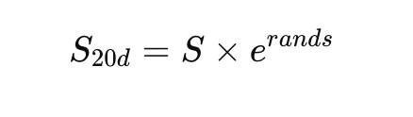

**Then I do the Option Price Calculation:**

then do the Monte Carlo simulations, compute 50,000 scenarios for the new call and put prices after 20 days.

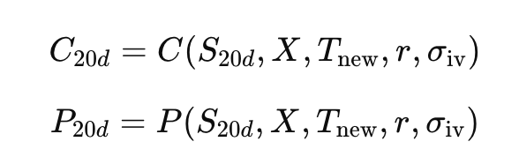

The PnL distribution is:

And then we can calculate:

VaR: The 5th percentile of the sorted PnL distribution.

ES: The mean loss beyond the 5th percentile.

The results are following:

**E:**

The Delta-Normal approximation and Monte Carlo simulation differ significantly in portfolio risk assessment. The Delta-Normal approximation is computationally simple and suitable for small price movements, but it assumes linear price changes and ignores second-order effects such as Gamma. As a result, its estimates can become highly inaccurate when stock prices experience large fluctuations. As shown in the figure, options clearly do not follow a linear relationship. Therefore, using the Delta-Normal method to estimate portfolio price changes in this case introduces a significant bias.

In contrast, the Monte Carlo simulation generates a large number of price paths to capture the portfolio’s non-linear characteristics. As a result, the bias between the Monte Carlo estimated portfolio price changes and the true price changes is minimal. However, Monte Carlo simulations require substantial computation time, whereas the Delta-Normal method is much simpler to compute.

Also, The returns of options do not follow a normal distribution but exhibit skewness and fat tails. Since the Delta-Normal method only considers Delta (Δ) and Theta (Θ) while ignoring Gamma (Γ), it tends to overestimate market risk, leading to higher VaR and ES values. In contrast, the Monte Carlo method, based on random simulations, can capture the nonlinear characteristics of options (including Gamma effects). As a result, the Monte Carlo-estimated VaR is closer to the actual risk, and it is generally lower than the Delta-Normal approximation.

Overall, **Monte Carlo simulation provides a better estimation for portfolios with non-linear characteristics,** whereas the **Delta-Normal approximation is suitable for linear approximations but not for non-linear portfolios, such as those containing options.**